**Demo Sales Application**

**Sales Region**

**Sales Person**

**Sale**

-------------------------

**Sales Region**

Name

Code(3 digit) //3 digit code to track sales region

Sales // sales are associated with sales region

Sales People //Sales people are connected with sales people

Active/Inactive //Sales region may active or inactive

**Sales Person**

First Name

Last Name

Sales

Sales Region

Active/Inactive

**Sales**

Amount($)

Date

Sales Region

Sales Person

**Add EntityFramework Nuget Package**

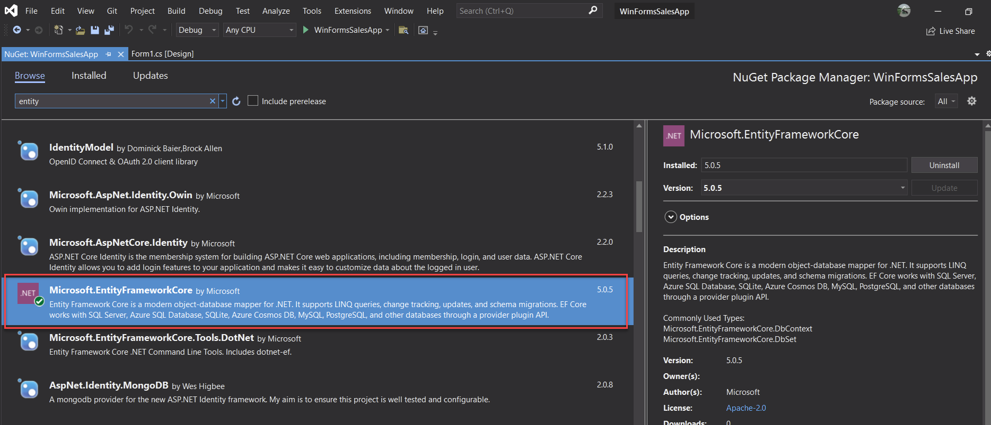

**Created basic models inside a Models Folder**

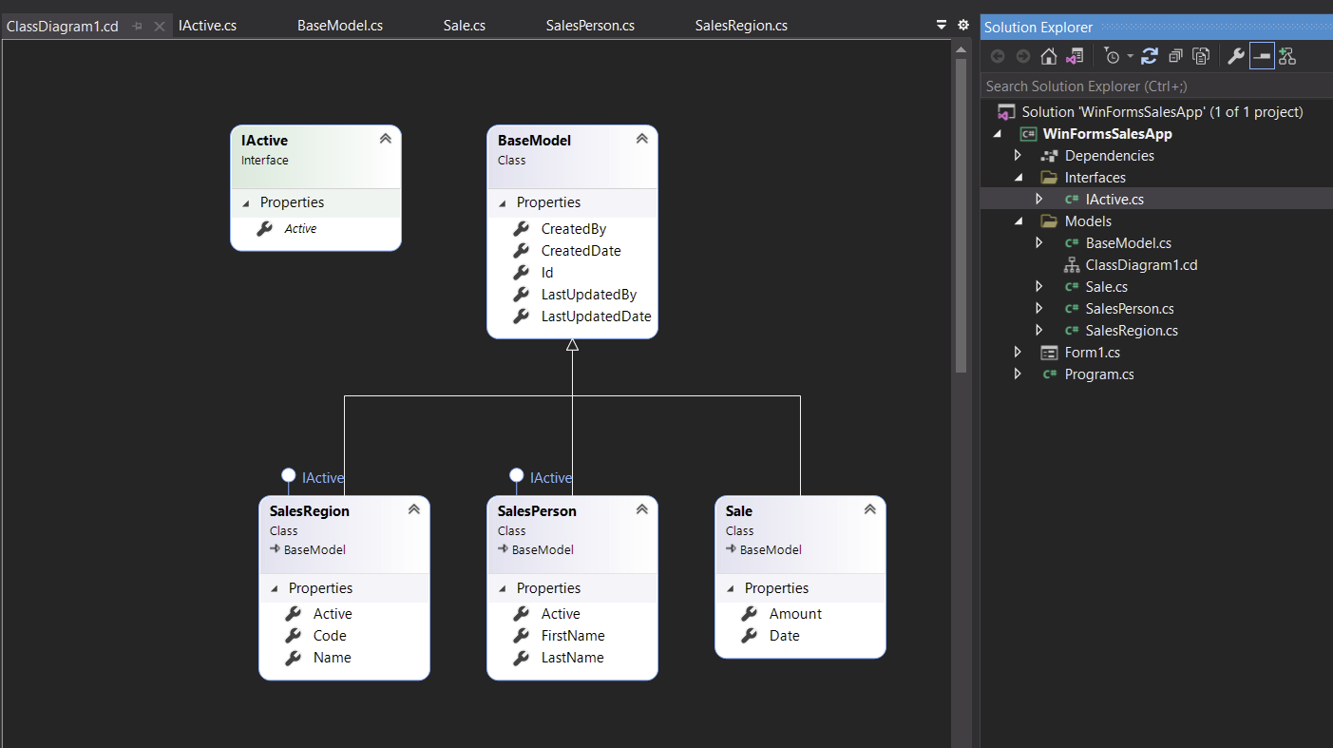

**Common Data Attributes**

**using System.ComponentModel.DataAnnotations;**

|  |  |
| --- | --- |
| **Attribute** | **Description** |
| **[Key]** | The Primary Key in the database table |
|  | |
| **[Column]** | The unique database key. For composite keys add [Key] to two or more properties. |
| **[MaxLength]** | The maximum length of a string. |
| [StringLength(3)]  **[MaxLength(3)]**  [MinLength(3)]  public string Code { get; set; } | |
| **[MinLength]** | The minimum required length of a string. |
| [StringLength(3)]  [MaxLength(3)]  **[MinLength(3)]**  public string Code { get; set; } | |
| **[NotMapped]** | Do not create a database column for the property. |
| **[Range]** | A numeric property must fit within the specified range. |
| [Required]  **[Range(0.01,100000.00)]**  public decimal Amount { get; set; }  or  [Required]  **[Range(0, double.MaxValue)]**  public decimal Amount { get; set; } | |
| **[Required]** | The property value is required (not null). |
| **[Required]**  [StringLength(100)]  public string FirstName { get; set; }  or  **[Required]**  [StringLength(3)]  [MaxLength(3)]  [MinLength(3)]  public string Code { get; set; } | |
| **[StringLength]** | A string property must fit within the specified range. |
| **[StringLength(100)]**  public string FirstName { get; set; }  or  [Required]  **[StringLength(3)]**  [MaxLength(3)]  [MinLength(3)]  public string Code { get; set; } | |
| **[Table]** | Change the name of the database table for a model. |

using Microsoft.EntityFrameworkCore; // .ToBindingList()

using System;

using System.Collections;

using System.Collections.Generic;

using System.Collections.ObjectModel; // for ObservableCollection<T>

using System.ComponentModel; // for ObservableCollection<T>

using System.Linq;

using System.Text;

using System.Threading.Tasks;

namespace WinFormsSalesApp.Models

{

class **ObservableListSource**<T> : ObservableCollection<T>, IListSource where T : BaseModel

{

private IBindingList _bindingList;

bool IListSource.ContainsListCollection { get { return false; } }

IList IListSource.GetList() {

return _bindingList ?? (_bindingList = this.ToBindingList());

}

}

}